ADAPTIVE FLOOD MANAGEMENT IN THAILAND: MODIFICATION OF OPERATION RULE CURVES

Gestion des inondations en Thaïlande Adaptive: modification des règles de fonctionnement Courbes
ARTHON SUTTIGARN¹; SOMCHIT AMNATSARN²; CHAIWAT PRECHAWIT³
ABSTRACT
Flood in the Chao Phraya River Basin has occurred several times in the past years: 1975, 1978, 1980, 1983, 1995, 1996, 2002, 2006, 2010 and 2011. In 2011, the most serve flood year, widespread flood covered a wide range of the central plain and extremely damaged throughout the area, because of many heavy storms hitting Thailand for a long time since late June to early October. The total amount of runoff in the river of Ping, Wang, Yom, and Nan joined together and was measured at gauging station C.2 was 4, 686 cubic meters per second but the capacity to manage the Chao Phraya River is limited at 2,860 cubic meters per second. Consequently, overflowing water along the bank of the river spilled over into lower-level areas of 28,000 square kilometres and caused the disaster effect as 45.7 Billion US dollar from the assessment of the World Bank (2012). To cope with the flood in Chao Phraya River, the Thai government assigned the involved organizations to study and implement on the integrated flood mitigation in this basin. There are two measures on flood mitigation: structural measure such as river improvement and Non-structural measure such as modification of reservoir operation rule curve. One interested of non- structural measure which will be mentioned in this paper is the modification of reservoir operation or modified operation rule curves of two large dams in the North of Bhumibol dam and Sirikit dam in order to maintain inflow water in Flood period and reduce the Flood volume to mitigate inundation in the central part of Thailand. This non-structural measure could be used with other non-structural or structural measures to mitigate the flood damage effectively in Chao Phraya River Basin.
RÉSUMÉ
Les crues dans le bassin de la rivière Chao Phraya a eu lieu à plusieurs reprises dans les dernières années: 1975, 1978, 1980, 1983, 1995, 1996, 2002, 2006, 2010 et 2011. En 2011, la plupart servent inondations année, une inondation généralisée couvert un large. gamme de la plaine centrale et extrêmement endommagé dans toute la région, en raison de nombreuses grosses tempêtes frappent la Thaïlande pendant une longue période depuis la fin Juin à début Octobre. Le montant total des eaux de ruissellement dans la rivière de Ping, Wang, Yom et Nan réunis et a été mesurée à la station de jaugeage C.2 a été 4 686 mètres cubes par seconde, mais la capacité de gérer la rivière Chao Phraya est limitée à 2860 cube. mètres par seconde. Par conséquent, l'eau déborde le long de la rive de la rivière a débordé dans les zones de niveau inférieur de 28 000 kilomètres carrés et a causé l'effet des catastrophes 45,7 milliards de dollars américains de l'évaluation de la Banque mondiale (2012). Pour faire face à l'inondation de Chao Phraya River, le gouvernement thaïlandais a attribué les organisations concernées pour étudier et mettre en œuvre sur l'atténuation intégrée des inondations dans ce bassin. Il ya deux mesures sur l'atténuation des inondations: des mesures structurelles telles que l'amélioration de la rivière et de mesure non-structurelles telles que la modification de la courbe de la règle de fonctionnement réservoir. Une intéressés de mesure non structurelle qui sera mentionné dans cet article est la modification du fonctionnement du réservoir ou courbes de règles de fonctionnement modifiés de deux grands barrages dans le barrage nord de Bhumibol et Sirikit barrage afin de maintenir l'eau d'entrée en période d'inondation et de réduire le. volume de Flood pour atténuer les inondations dans la partie centrale de la Thaïlande. Cette mesure non structurels pourraient être utilisés à d'autres mesures non-structurelles ou structurelles pour atténuer efficacement les dommages d'inondation dans Chao Phraya River Basin. (Translated by Google Translate)
Keywords: Adaptive Flood Management in Thailand, Non-structural Measures, Operation Rule Curve of Dams, Chao Phraya River Basin
¹ [Civil Engineer], [Royal Irrigation], [811 Samsen Road, Dusit District, Bangkok 10300,Thailand],[asut999@gmail.com]
² [Civil Engineer], [Royal Irrigation], [811 Samsen Road, Dusit District, Bangkok 10300,Thailand],[somnatsan@yahoo.com]
³ [THAICID Committee] [THAICID], [811 Samsen Road, Dusit District, Bangkok 10300,Thailand], [c_prechawit@hotail.com]
INTRODUCTION
The year 2011 was really a year of flood disasters in Thailand. There were several places where floods had created disasters, including the most severe one in the Great Chao Phraya river basin. The Chao Phraya river basin is a large river basin where the watershed area is about 163,000 square kilometers. It is composed of four major tributaries from North, namely Ping, Wang, Yom and Nan and also two tributaries from the central Plain such as the Sakae Krang and Pasak River, including the Thachin River which diverges from the Chao Phraya River and flows to the gulf of Thailand as shown in Figure 1.

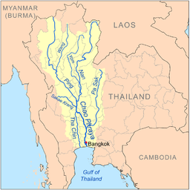
Figure 1: The Chao Phraya River and its tributaries

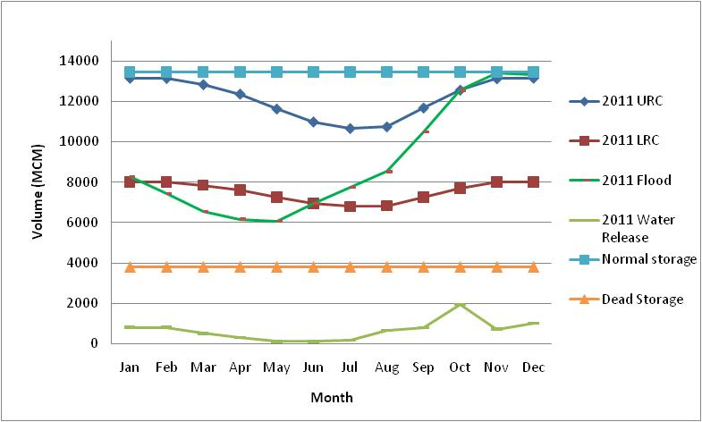

Figure 2: Bhumibol dam Operation Rule curves and water storage in 2011
Look back in 2011 water situation, start at year 2010, it was a drought year as a result of El Nino phenomenon, the usable volume of water stored from the Bhumibol dam and Sirikit dam remain only 535 million cubic meter (MCM), On May 1, 2011 that was the beginning of rainy season of Thailand, water stored in the Bhumiphol dam was 45% or 6,066 MCM and 1,200 MCM below the Lower Rule Curve (LRC), while the water storage in Sirikit dam was 50% or 4,768 MCM and 1,300 MCM below the LRC. After May 1, 2011, the rainy season began, Inflow increased continuously until June 1, 2011 when water storage in Bhumiphol dam reached the LRC. Water storage still increased as regular raining season until it began with the tropical storm Haima which caused heavy rain from 24 to 26 June, 2011. The storage was sharply increased. Then, followed by tropical storm Nock-ten which caused very heavy rain and lots of water flowed into dam between July 30, and August 3, 2011. The water storage was up to higher than 63% of storage capacity. Then, the strong low pressure troughs also passed over the North for a series of period from 10 to 12 August, 15-19 August and 8-12 September, 2011 yielding large inflow into the Bhumibol dam. Finally, the series of tropical storm Haitang on September 28, tropical storm Nesat from September 30 to October 1 and tropical storm Nagae from October 5 to 6 caused the water reached the Upper Rule Curve (URC) and reached the Normal Storage Level (NSL) on early October. The Government had to manage the water level not to exceed the NSL by increasing the water release from the dam through spillway and river to downstream between August and Mid-September. The situation was very severe in lower Chao Phraya River as a result of the water release from Sirikit dam, Nan river basin and central flooding. The release of water still was done between Mid-September and early October in order to save the dam. The high record inflow forced Bhumibol dam to release more than 100 MCM for a few days in October. The result of continuous heavy rainfall in North and Central plain made the Catastrophe flood in 70 year history of Thailand.
CRITERIA FOR MODIFICATION OF OPERATION RULE CURVE
After the 2011 flooding, a proposal for revision of the operation rules of 33 large dams, including Bhumibol and Sirikit dams in Thailand was approved by the Strategic Committee for Water Resource Management (SCWRM). This was one of the proposals as flood prevention measures after the 2011 flood. The revision had cooperated among several organizations such as Royal Irrigation Department, Electricity Generating Authority of Thailand (EGAT), Metrological Department, Ministry of Interior, Local Administrative Organization to revise the rule curve and criteria. The criteria had been set as shown in Table 1.
Table 1 shows the conditions, Water Elevation in a reservoir and Criteria on Reservoir Operation
Condition | Water Elevation in Reservoir | Criteria on Reservoir Operation
1  2  3  4  5  6 | Higher than a Normal High Water Level (NHWL)  Higher than an Upper Rule Curve (URC)  Higher an URC and incline to Flood situation  Between URC and LRC (Lower Rule Curve)  Lower than LRC  Reach minimum water level (MinWL) | -Release excess water through Spillway  -Release water to supply to all needs  -Release more water through river outlet to spare more storage for flood  -Supply water to all needs  -Release water as necessary and priority  -Stop supply water from the reservoir

Three procedures were used to adjust the reservoir rule curves i.e., probability based rule curve, flood control and mitigation emphasis which the goal is to implement a plan in advance by supplying water from the reservoir in the dry season as possible to reserve a space for water during the rainy season and reduce the amount of water during the flood crisis, especially from August to October, and the risk on the following year drought less than 20% of water demands. To select the appropriate criteria on Reservoir Operation Rule Curves above, it must simulate the situations in two steps:
- Simulate Reservoir Operating System using HEC-3 program with a principle of the water balance. The simulation technique requires monthly long-term hydrological data, which cover the different scenarios as input data, including inflow, rainfall into the reservoir, water evaporation and seepage inside the reservoir, and the outflow. The simulations were calibrated of accuracy in accordance with the study area and proceed until the model can mimic to the appearance and behavior of the system.
- Take the modified Rule Curve which was adjusted with Probability Based Rule Curve at any risks as input data coping with critical water situations of excess water, average water and less water to check the results in terms of the amount of water overflowed the reservoir, water monthly release, especially during the excess water crisis from August to October, water yearly release and release for irrigation demand. Then, select the Probability Based Rule Curve from the results of the simulation which were satisfactory and meet the conditions of operational goal to reduce flooding downstream.
RESULTS AND DISCUSSION
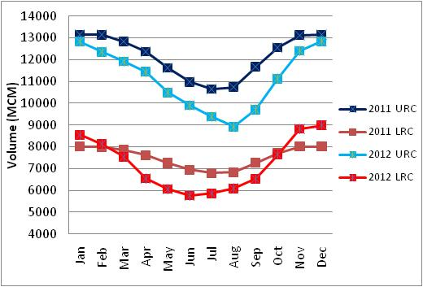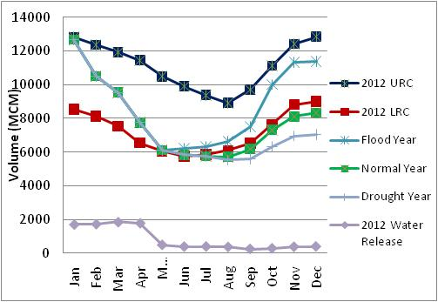
Figure 3 (Left): Results of Reservoir Operation Rule Curve Modification for Bhumibol dam in 2012
Figure 4 (Right): Forecasting of water storage in case of Flood year, Normal year or Drought year
Figure 3 shows a comparison between 2011 old Operation Rule Curve and 2012 modified Operation Rule Curve for Bhumibol dam. It shows that 2012 URC throughout the year was adjusted under 2011 URC to increase a gap of reservoir management for flood crisis. The maximum gap of 1,822 MCM from old and new URC was in August, where the storage at the new URC was about 9,000 MCM or at 66% of storage capacity. The LRC was modified differently from URC i.e., in January to February and October to December, where the LRC was adjusted above the old LRC. The maximum gap between them was 1,185 MCM in May, which is beginning month of rainy season or the lowest capacity of reservoir operation is 45% of the storage capacity or 6,060 MCM to accommodate inflow. However, after modifying the rule curve, forecasting shows that water storage might be under 2012 LRC in case of Normal year and Drought year as shown in Figure 4. Therefore, water management will need to balance needs and the risk of water shortage in the following year.
CONCLUSIONS AND RECOMMENDATIONS
- Study the management of water in the reservoir at this time prepared under the Action Plan to alleviate flood problems urgently. The water situation in 2011, which was a new record for a critical review, will be taken into account for operating the reservoir properly.
- Water management requires in advance. Get to reserve space for the water in the rainy season and the drainage is minimal in the period from August to October in order to minimize the impact on the flooding in the lower areas that may occur.
- Water management will need to maintain balance in management for agriculture, consumption, floods and ecological conservation as well as a minimal risk of water shortages in the following year.
- The criteria for water management in a reservoir should be updated periodically to keep water resource in accordance with rainfall-runoff, inflow, water demands and changes in reservoir capacity, including the impact of flooded areas downstream.
REFERENCES
Water management Division, office of water management and hydrology, 2012: The study of Modified Criteria for Operation Rule Curve in reservoir, page 1-27.
World Bank. Thailand Floods 2554 Rapid Assessment for Resilient recovery and reconstruction Report, DRAFT Flood Control, Drainage and Irrigation Chapter – 6 December 2011.

